**Git: What is it and Why Is It Useful?**

### **Slide 2: What is Git?** What is Git?

**Content:**

* Git is like a magic notebook that helps people keep track of their work.
* It's used by computer programmers to save and organize their projects, like making a game or website.
* Imagine writing a story, and Git helps you save every version, so you never lose anything!

**Image:** You could use a simple image of a notebook or version control graphic.

### **Slide 3: Why Do People Use Git?**

**Title:** Why Do People Use Git?

**Content:**

* **Keep track of changes**: Git helps you keep track of all the changes you make to your project.
* **Go back in time**: If something goes wrong, you can go back and fix it, just like having a time machine for your work!
* **Work with friends**: Git helps you and your friends work together on the same project without getting in each other's way.

**Image:** An image of people working together on a project (teamwork).

### **Slide 4: How Does Git Work?**

**Title:** How Does Git Work?

**Content:**

* **Snapshots**: Git takes "snapshots" of your work every time you make a change. It’s like taking a picture of your project at different times.
* **Save Changes**: Whenever you finish something, Git lets you save the "picture" of your work. You can save small changes, or big ones!
* **Compare Versions**: Git can show you how your project looked before and after each change.  
  .

### **Slide 5: Git Commands (What You Type)**

**Title:** Git Commands (What You Type)

**Content:**

* **git init**: This starts a new project with Git! It’s like setting up a new notebook for your work.
* **git add**: This tells Git to pay attention to the new changes you've made. It’s like saying, “Hey, look at what I did!"
* **git commit**: This saves the changes and makes a record of them. It's like saying, “I’m done for now, I’ll save this page!”
* **git push**: If you want to share your project with your friends, you can "push" it to the cloud (like putting it on a high shelf everyone can see).
* **git pull**: This lets you grab the latest changes from your friends, just like downloading their updates.

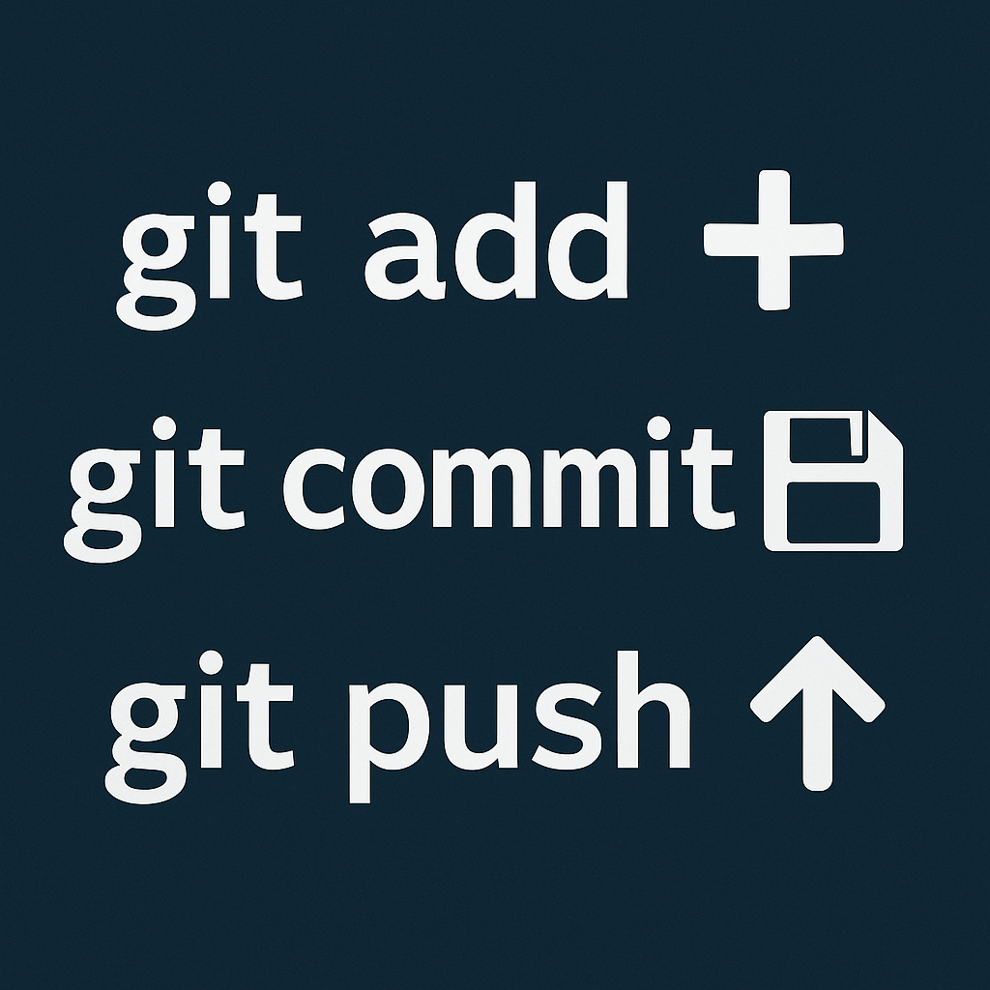

### **Slide 6: Git Helps Us Work Together**

**Title:** Git Helps Us Work Together

**Content:**

* If you and your friend are both working on the same project, Git helps you both work without messing up each other's work!
* Git lets you both make changes to the project, then "merge" your changes together without losing anything.

**Image:**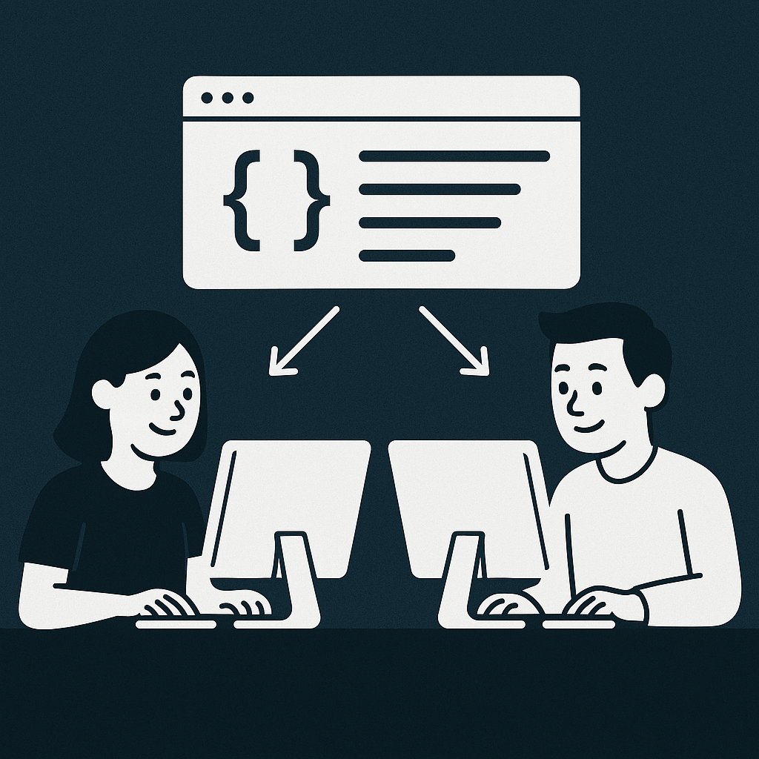

### **Slide 7: GitHub - Share Your Work with the World**

**Title:** GitHub: Where You Share Your Projects!

**Content:**

* GitHub is like a big playground for programmers.
* Once you use Git, you can upload your project to GitHub, and others can see it or help you improve it!
* You can show off your cool game or website to your friends and family.

**Image:**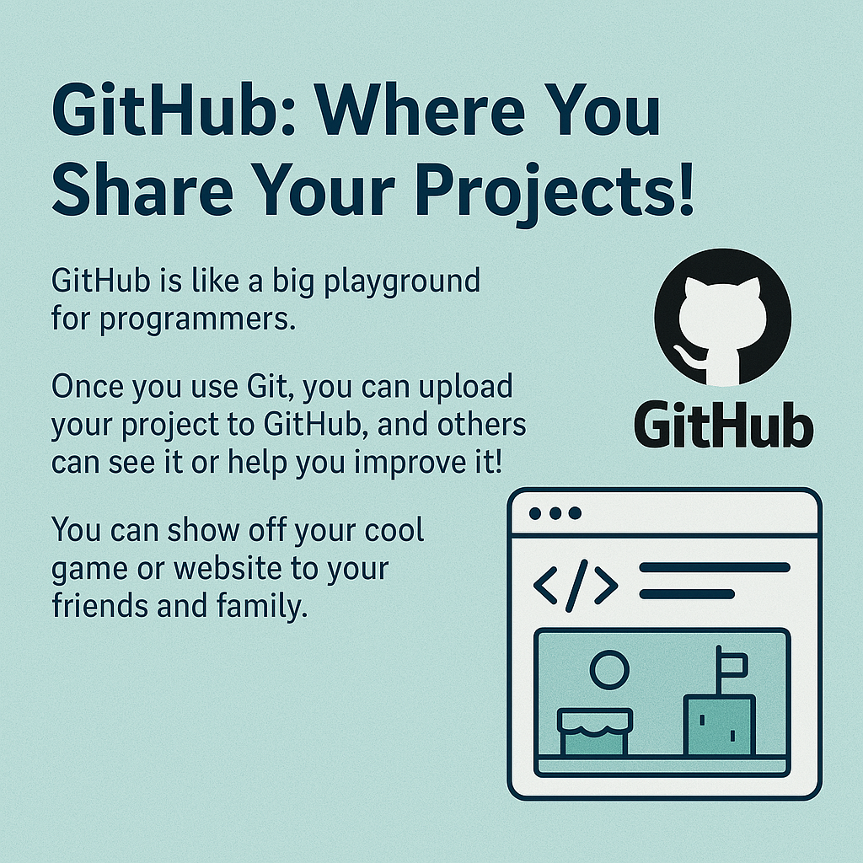

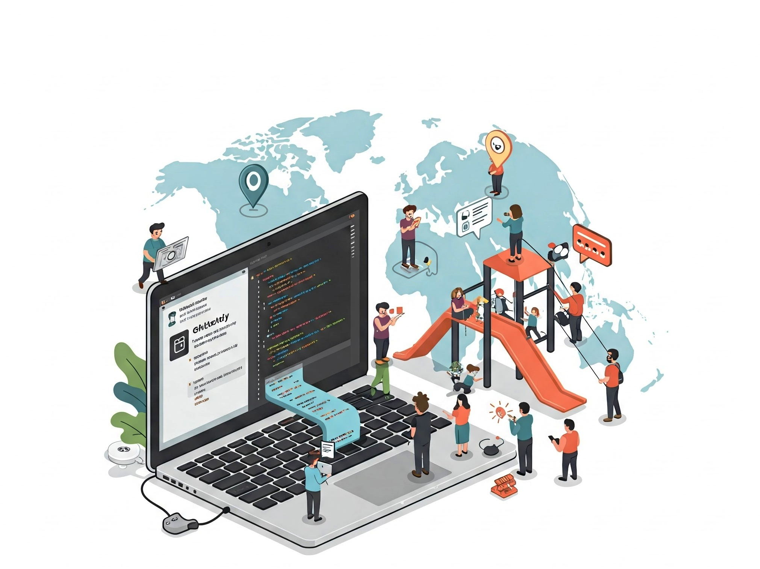

### **Slide 8: Why Git is Like a Superpower**

**Title:** Why Git is Like a Superpower

**Content:**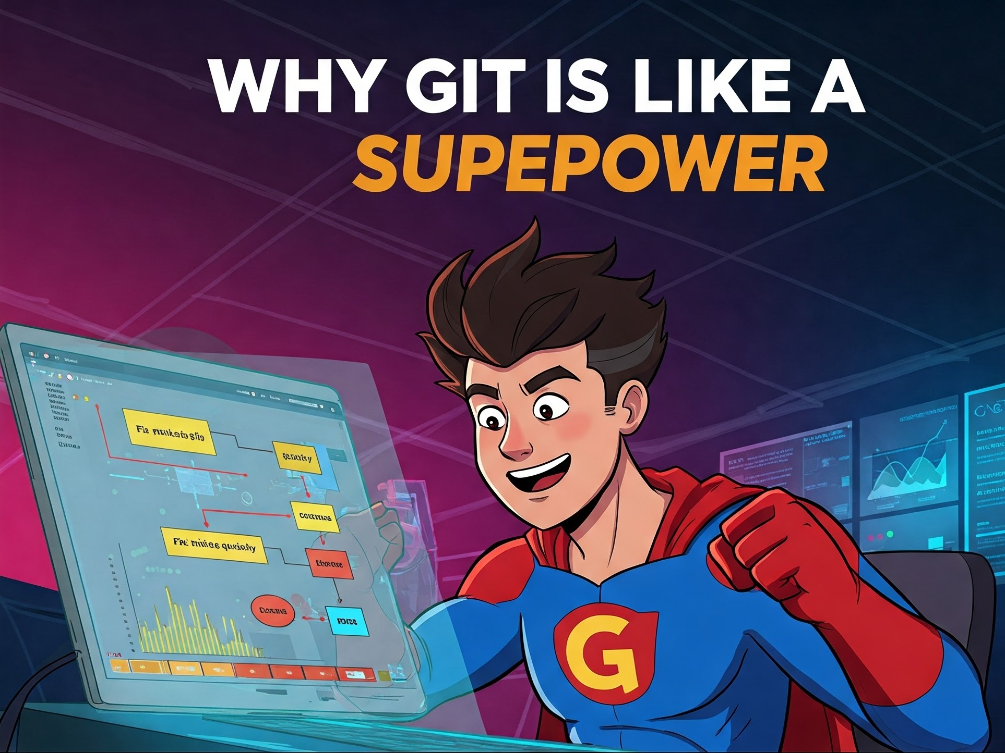

* Git is like a superpower for programmers. It helps them:  
  + **Fix mistakes** quickly.
  + **Save time** by remembering everything they do.
  + **Work together** with people all over the world.  
    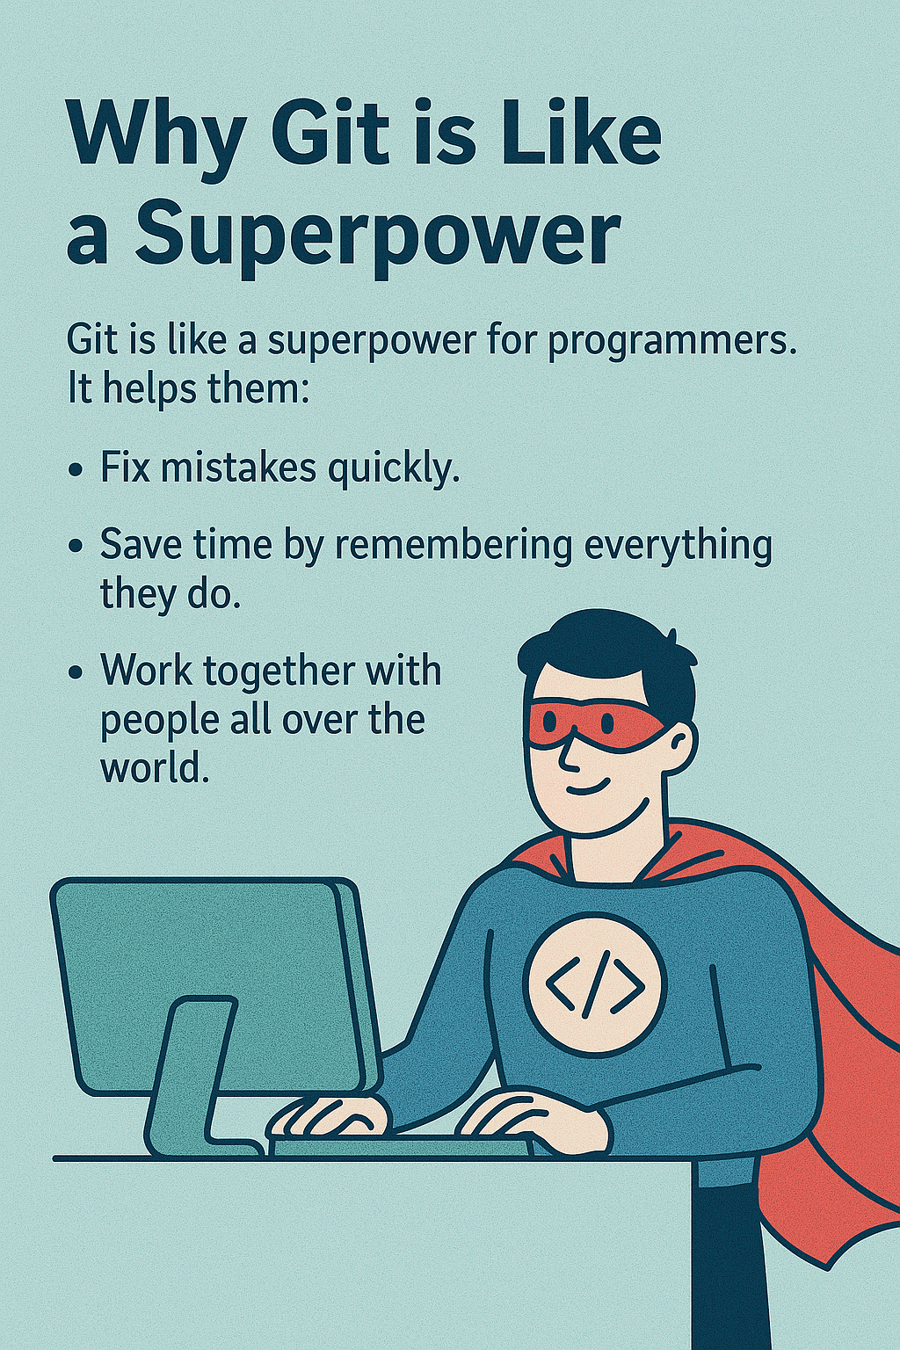

### **Slide 9: Summary – Git in One Sentence**

**Title:** Git in One Sentence

**Content:**

* Git is a tool that helps you save, share, and organize your projects so you never lose anything and can work with your friends.

**Image:** An image of a computer or a group of people working together with smiles!

### **Slide 10: Thanks for Learning About Git!**

**Title:** Thanks for Learning About Git!

**Content:**

* You are now a Git explorer!
* Keep using Git to make cool projects and share them with your friends.